Class: CS-340-10873-M01 Client/Server Development

7-2 Project Two: README File

Student: Margarita Kiseleva

Date: 06/17/2024

***Project Two – Grazioso Salvare – Readme File***

Contents

About the Project 1

Motivation 2

Getting Started 2

Installation 2

Usage 3

Mongo Shell 3

Code Example 4

Tests 6

Contact 17

# **About the Project**

The purpose of this project is to provide software for the company Grazioso Salvare, which searches for dogs that are suitable for rescue training. Grazioso Salvare works with five animal shelters located in Austin, TX. Those shelters provide the company with the necessary data regarding various dogs available for training. It is well known that certain types of training are more effective with specific types of dogs. Thus, to maximize the training efficiency, Grazioso Salvare is seeking a software application that could work with the data provided by the animal shelters to locate the dogs that will be best for particular training programs. The first project submitted within this course enabled CRUD functionality for MongoDB. This project builds upon the previous one, and it provides a dashboard as well as the database interface logic including dashboard attributes.

# **Motivation**

The main purpose of this project is to address specific critical needs of Grazioso Salvare company. It allows the company to effectively search for the best dogs suitable for their training programs. This application will improve the effectiveness of Grazioso Salvare training operation in a way that they can dedicate more time to training. Additionally, given that dogs trained by the client are used in different types or rescue projects, this application will broaden the positive impact Grazioso Salvare makes on society.

# **Getting Started**

To get a local copy up and running, follow these steps:

1. Log Into your Apporto account;
2. Open your Terminal application to access MongoDB and the mongo shell;
3. Upload the Austin Animal Center (AAC) Outcomes data set into MongoDB by importing a CSV file using the appropriate MongoDB import tool;
4. Open your mongo shell;
5. Create a new user account called “aacuser” for the database AAC in the mongo shell.
6. Write down the password for the aacuser account and keep it handy.
7. Modify the part of the Python code by editing the connection variables to reflect your own instance of MongoDB;
8. Modify the Python testing script in Jupyter Notebooks.
9. Follow the generated link that will take you to the interactive dashboard.
10. Apply different filters and take a note of the data displayed by the charts and the map.

# **Installation**

In order to work with this local copy, you will need the following modules:

* Access to Linux Terminal;
* Latest version of MongoDB;
* Latest version of Jupyter Notebook;
* Current version of Python.

# **Usage**

This project includes CRUD functionality that allows to create, read, update, and delete documents from the Mongo database. The developed dashboard offers several interactive features to the users. It allows us to sort and filter data through columns, display a pie chart as well as a bar graph representing data, and display the location of animals on a map.

# **Mongo Shell**

Before we can start working on the Python code, it is necessary to create a user account in the mongo shell to ensure user authentication to the database.

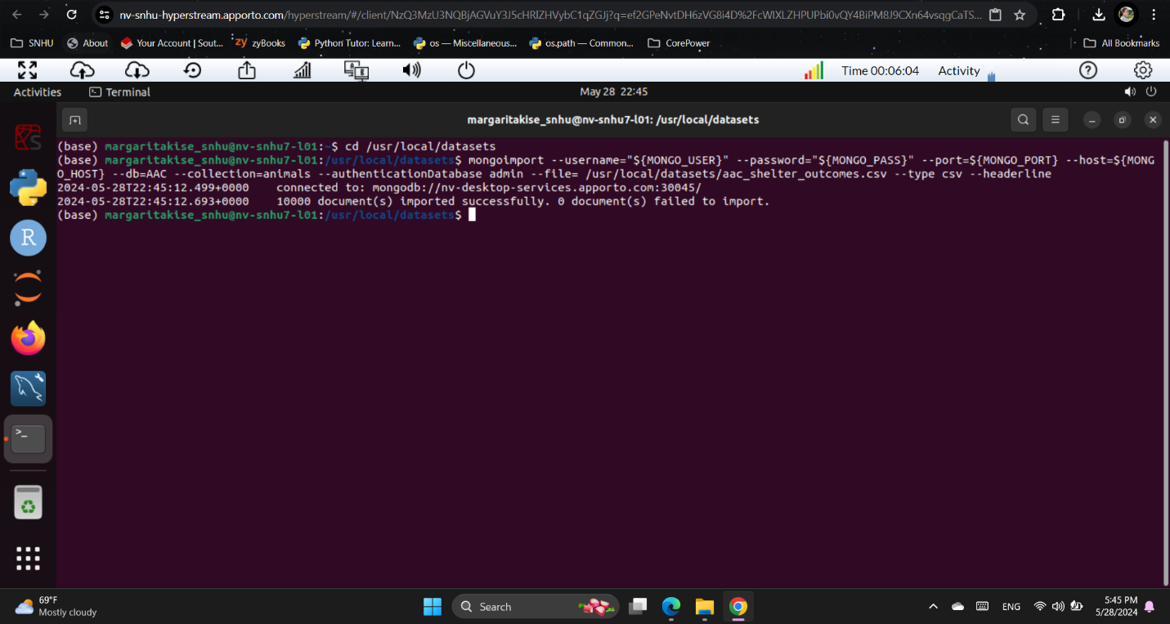

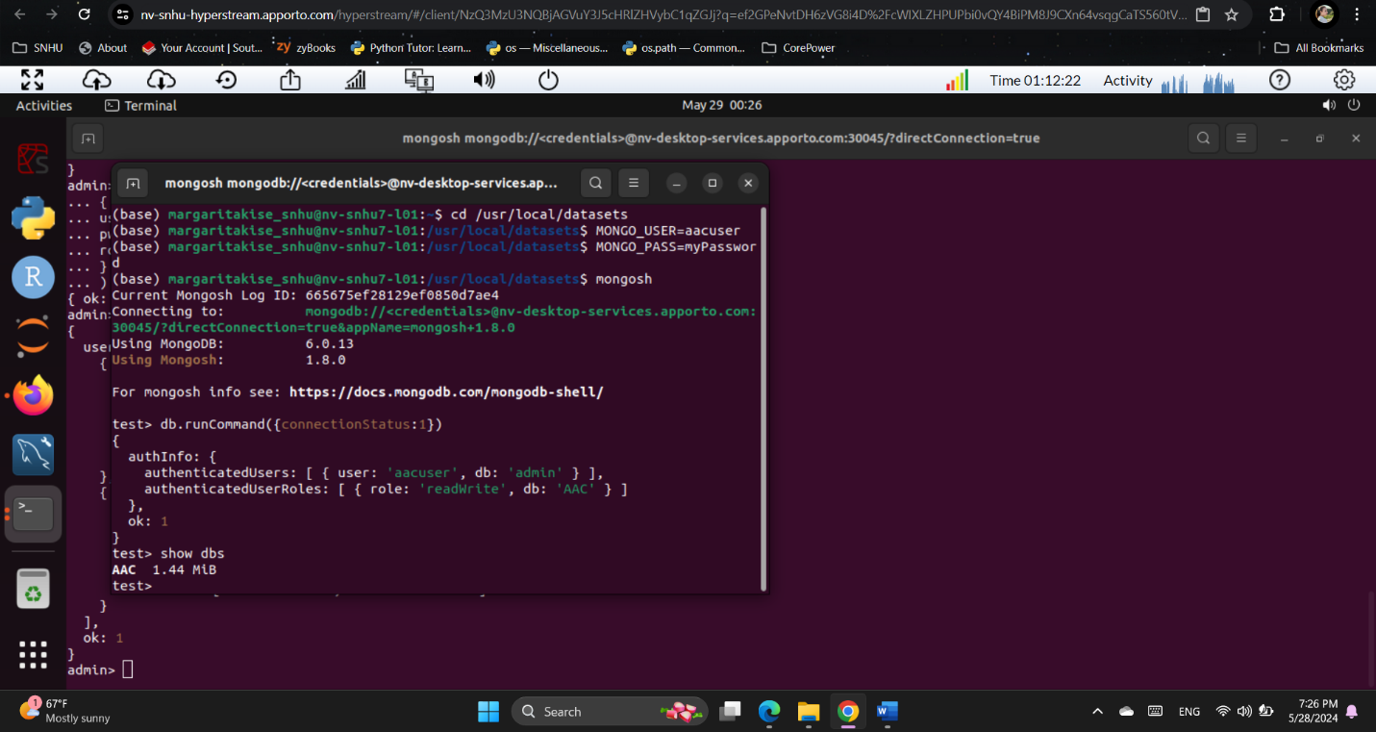

# **Code Example**

The constructor for the AnimalShelter class initializes the MongoDB server.

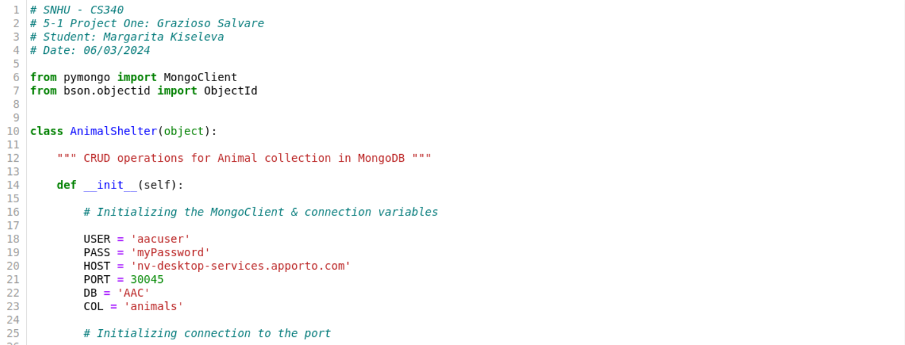

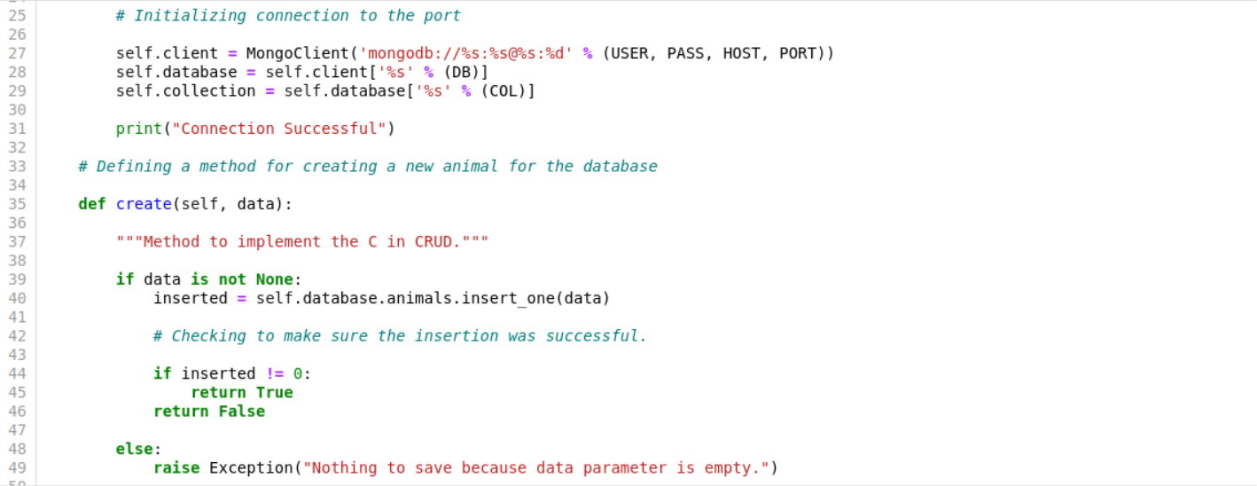

The method create() is used for adding a new item to the database. This method takes one argument in the form of a dictionary.



The method read() is used for finding and printing all the searched items from the database. This method takes one argument in the correct MongoDB format.

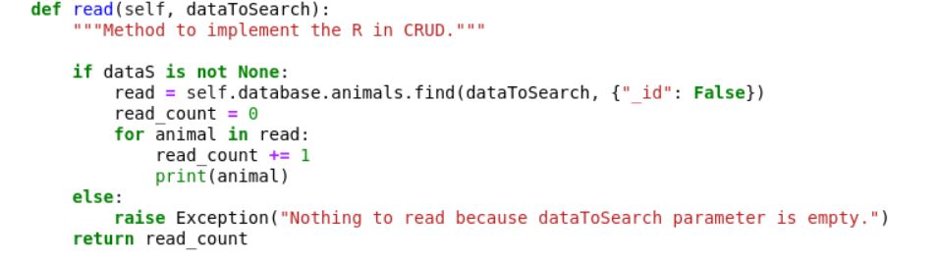

The method update() is used for finding, updating, and printing all the searched items from the database. This method takes two arguments in the correct MongoDB format.

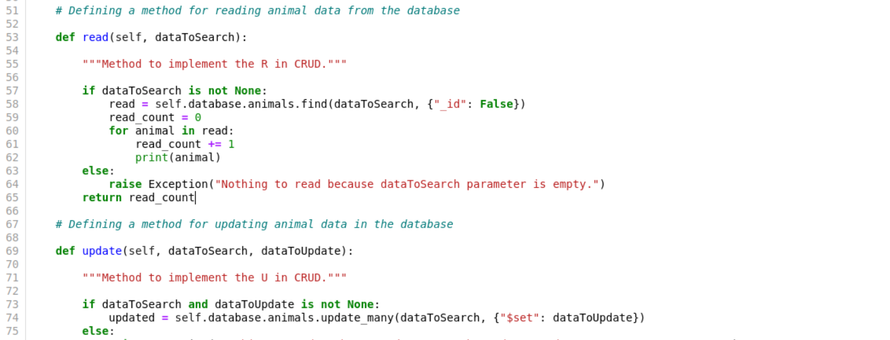

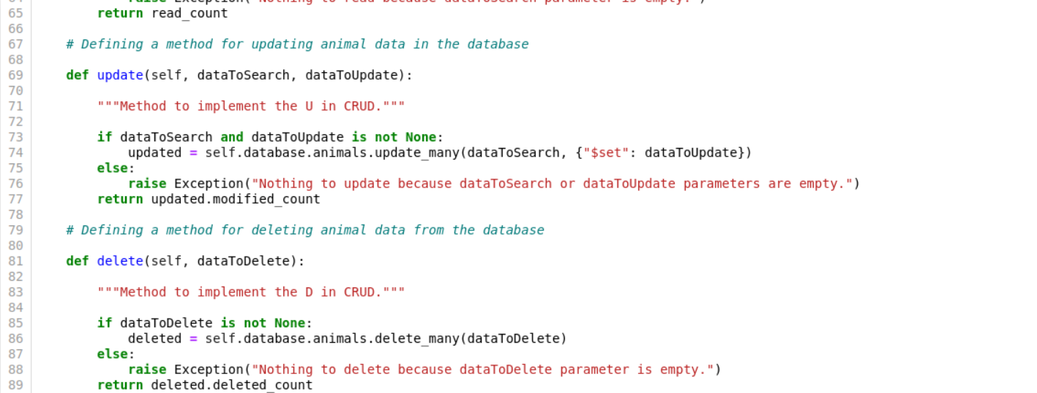

The method delete() is used for finding, deleting, and printing all the searched items from the database. This method takes one argument in the correct MongoDB format.



As is demonstrated on the screenshots above, all the methods handle exceptions and notify the user if the data input is not correct.

# **Tests**

We begin working in Jupyter Notebook by setting up the Jupyter version of Dash. Then we configure the necessary Python module imports for dashboard components, OS and plotting routines.

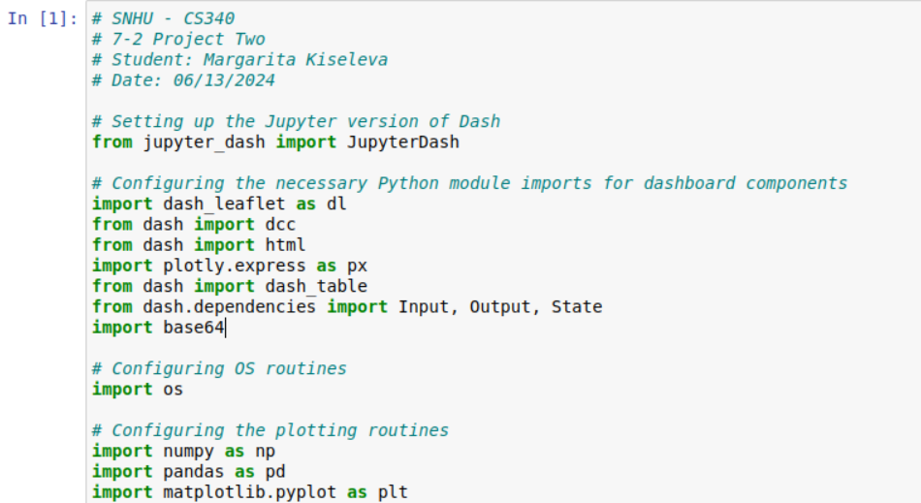

Then we import CRUD Python module and provide our own MongoDB authentication information.

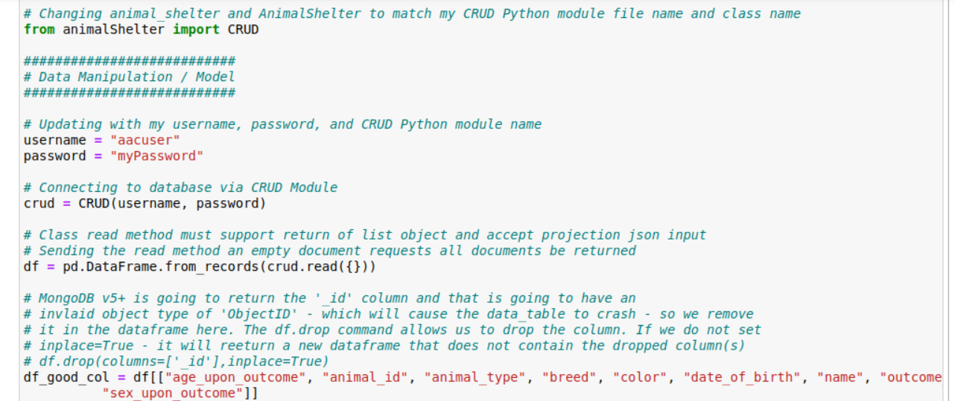

We proceed by creating a dashboard design. We add Grazioso Salvare logo, specify the dashboard’s parameters, and create a unique identifier.

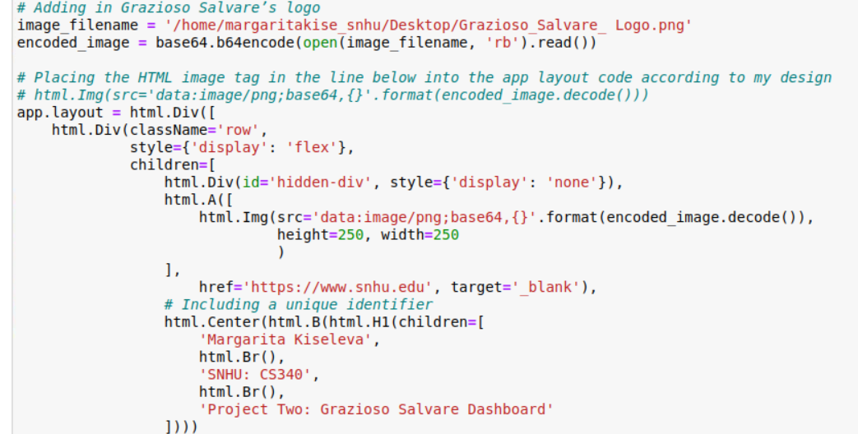

The next step is to set up the interactive features for the dashboard keeping in mind the need to keep it user friendly and elegant.

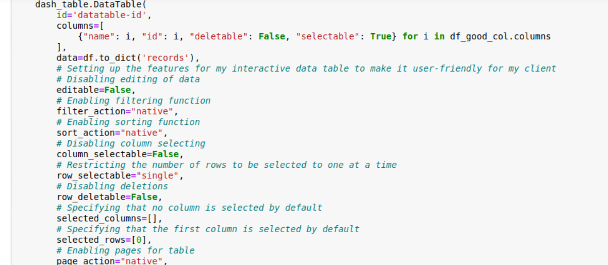

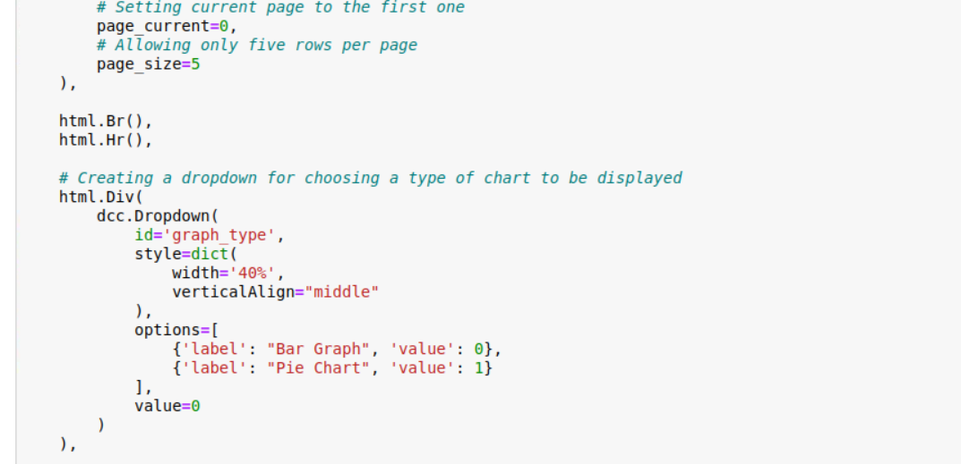

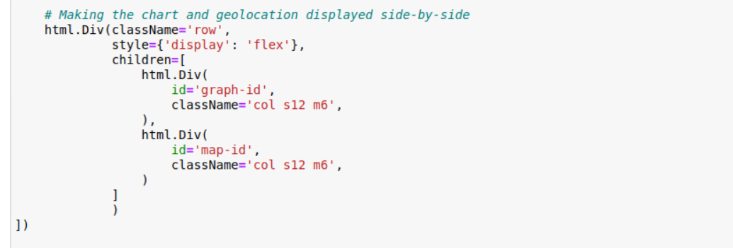

We continue by configuring the controller and creating different search filters.

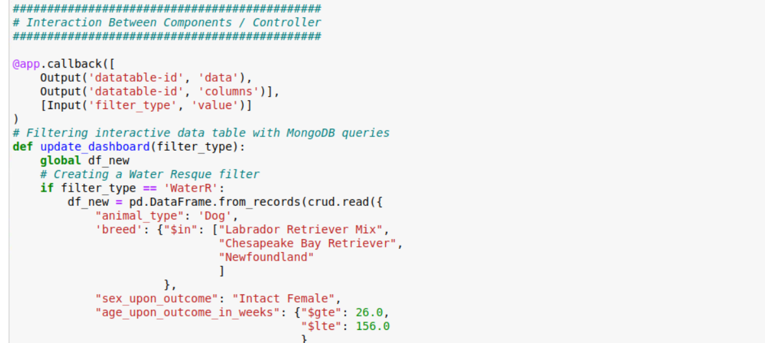

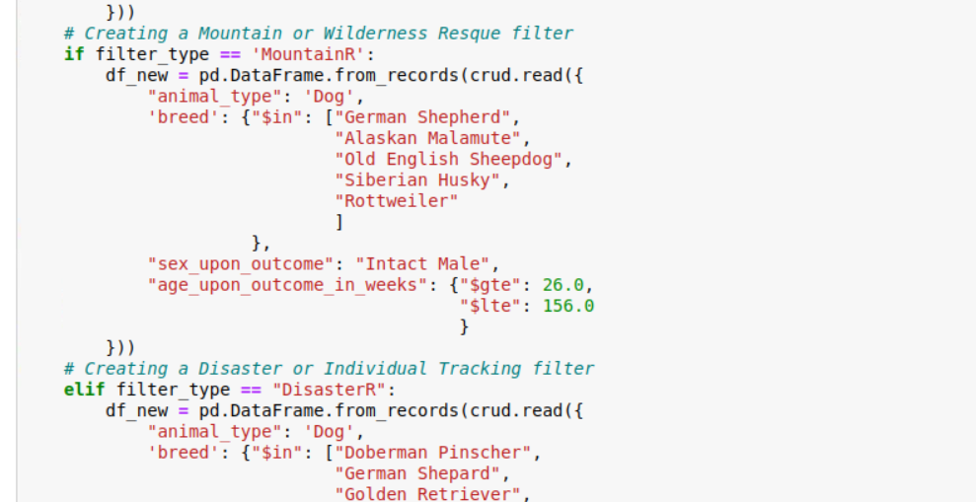

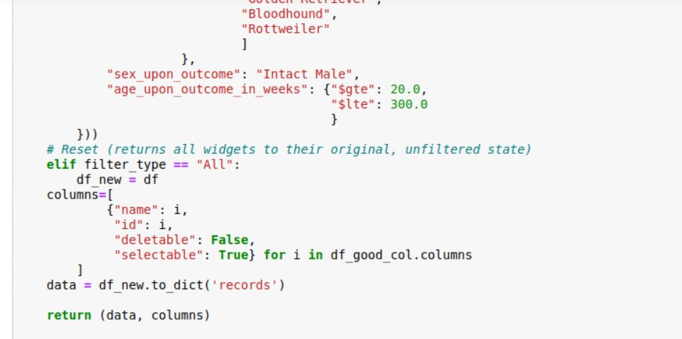

The next step is to add charts representing data. We create a pie chart and a histogram.

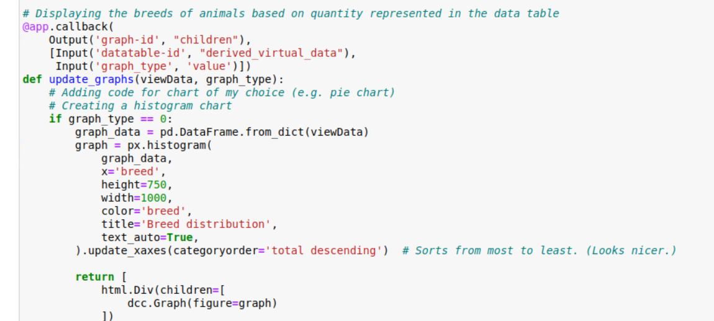

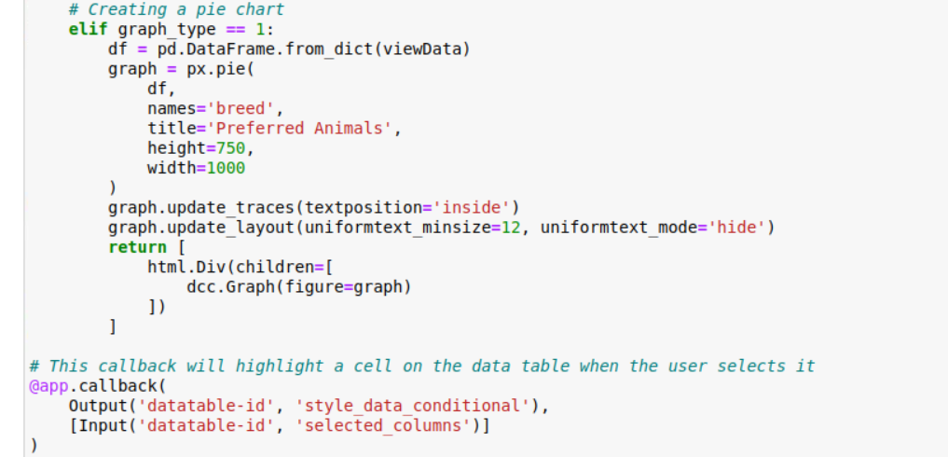

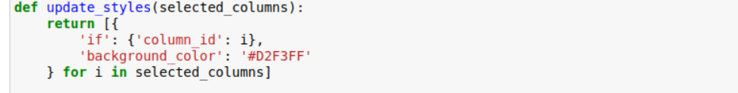

Finally, we create a callback for updating the geo-location chart for the chosen data entry.

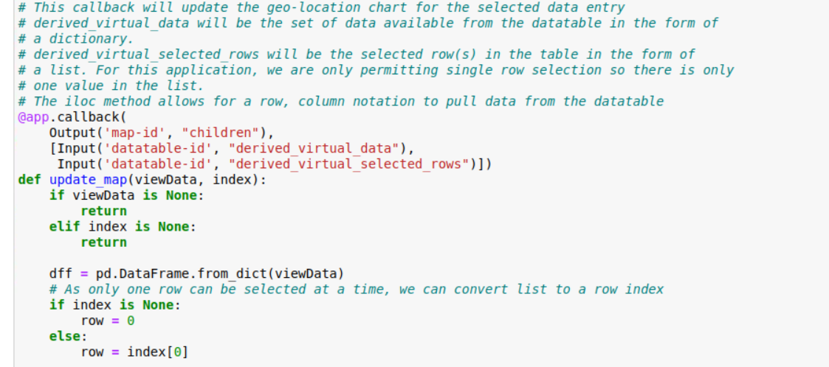

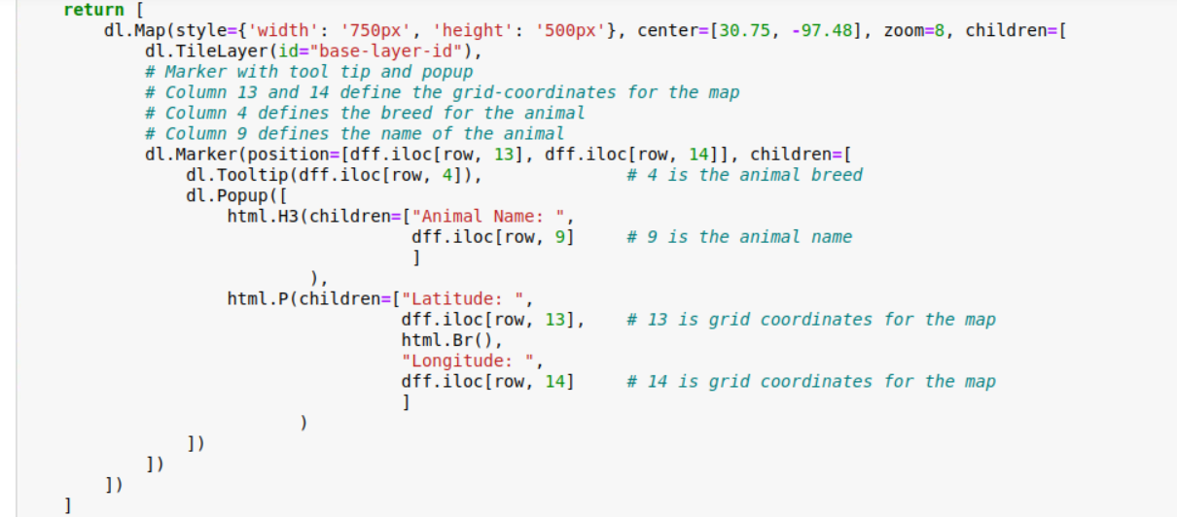

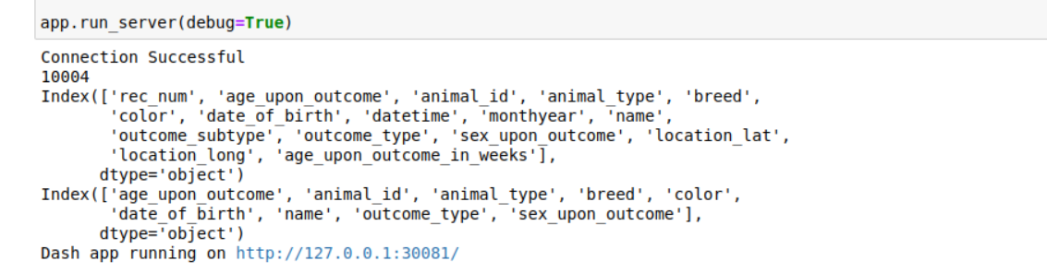

Then, we follow the generated link which takes us to the Grazioso Salvare dashboard. This dashboard displays the company’s logo, a unique identifier with the student’s name, a table containing five rows of data, a dropdown of charts, and a geolocation map. Above the table, there is a number of clickable filters. Those filters, once applied, display information concerning dogs suitable for a particular rescue type.

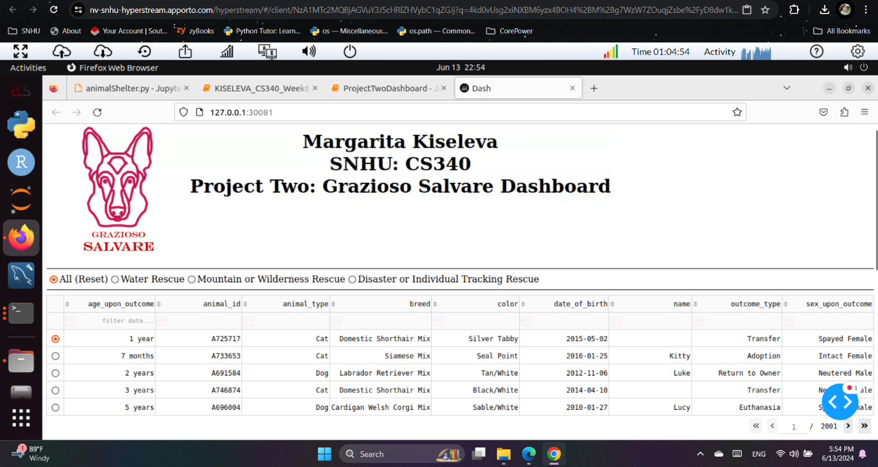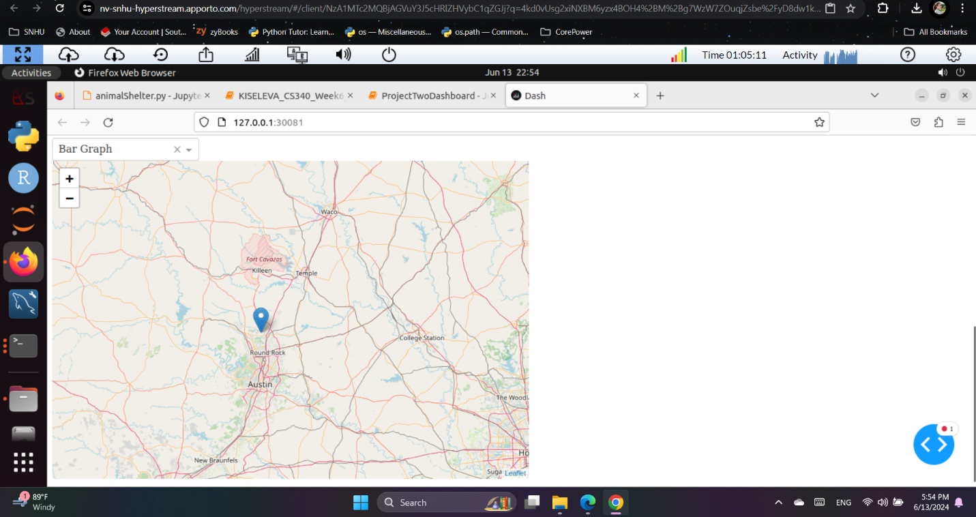

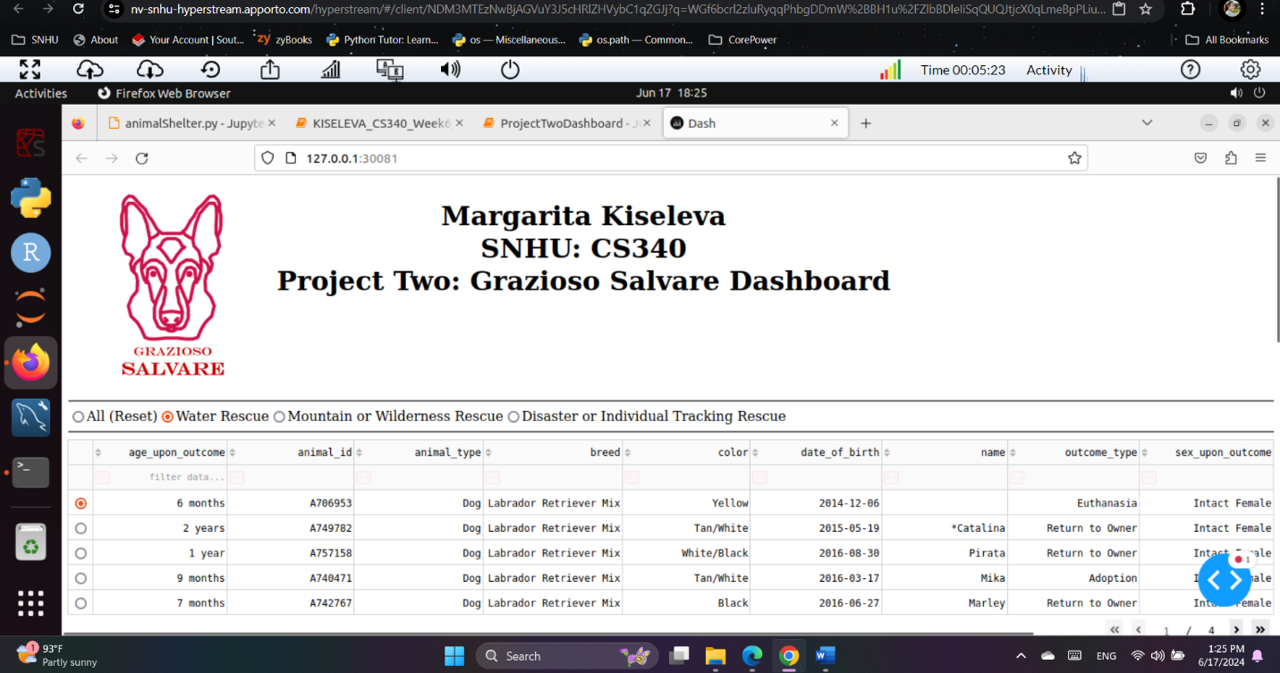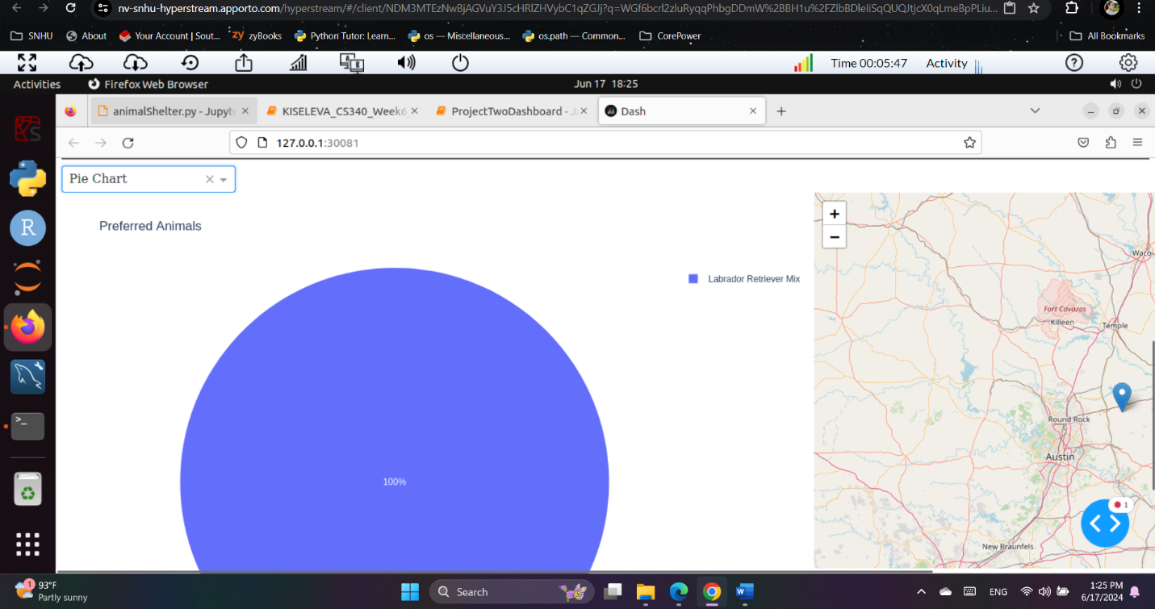

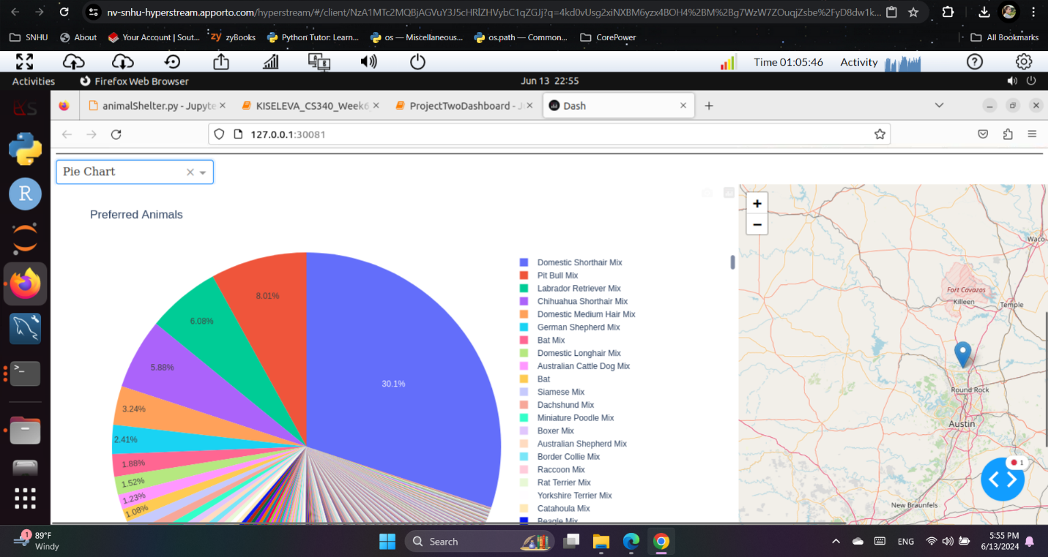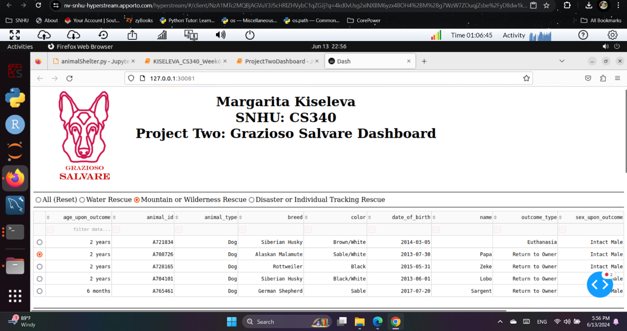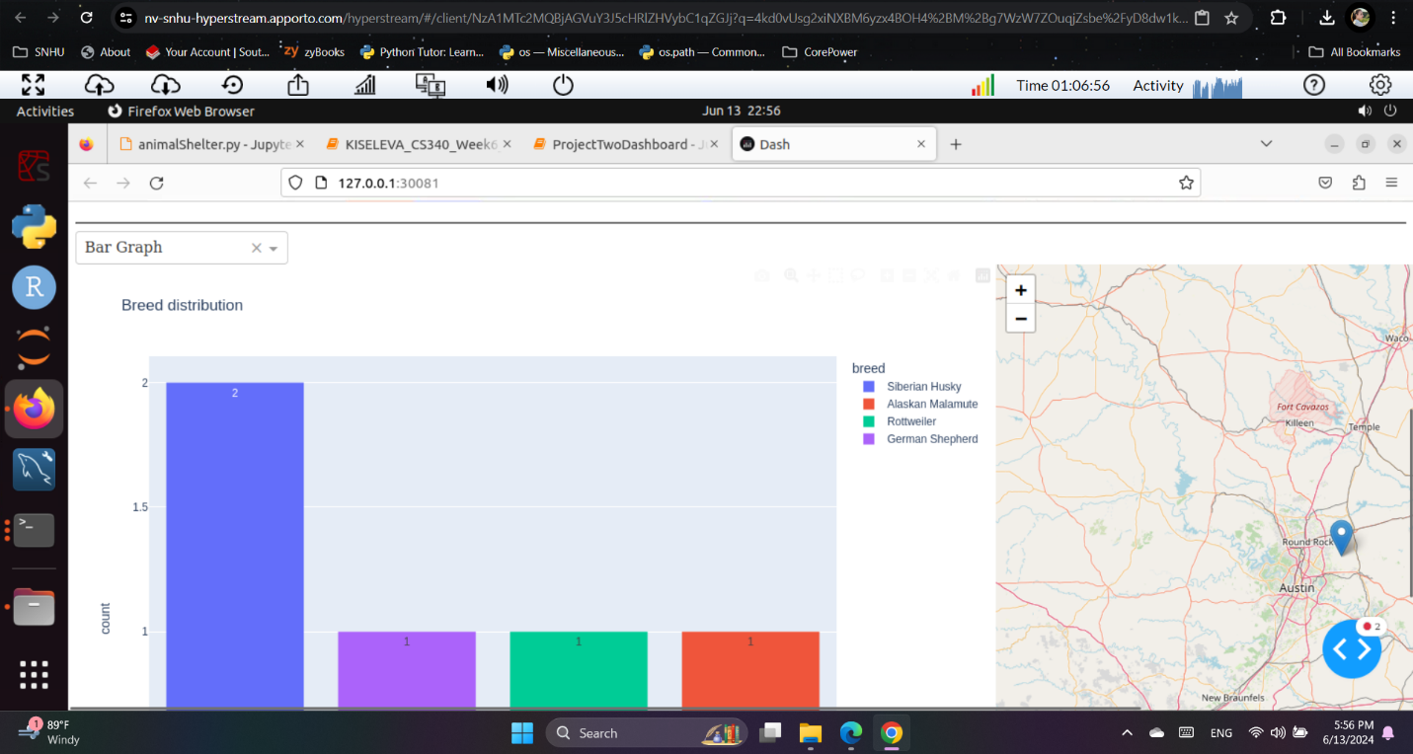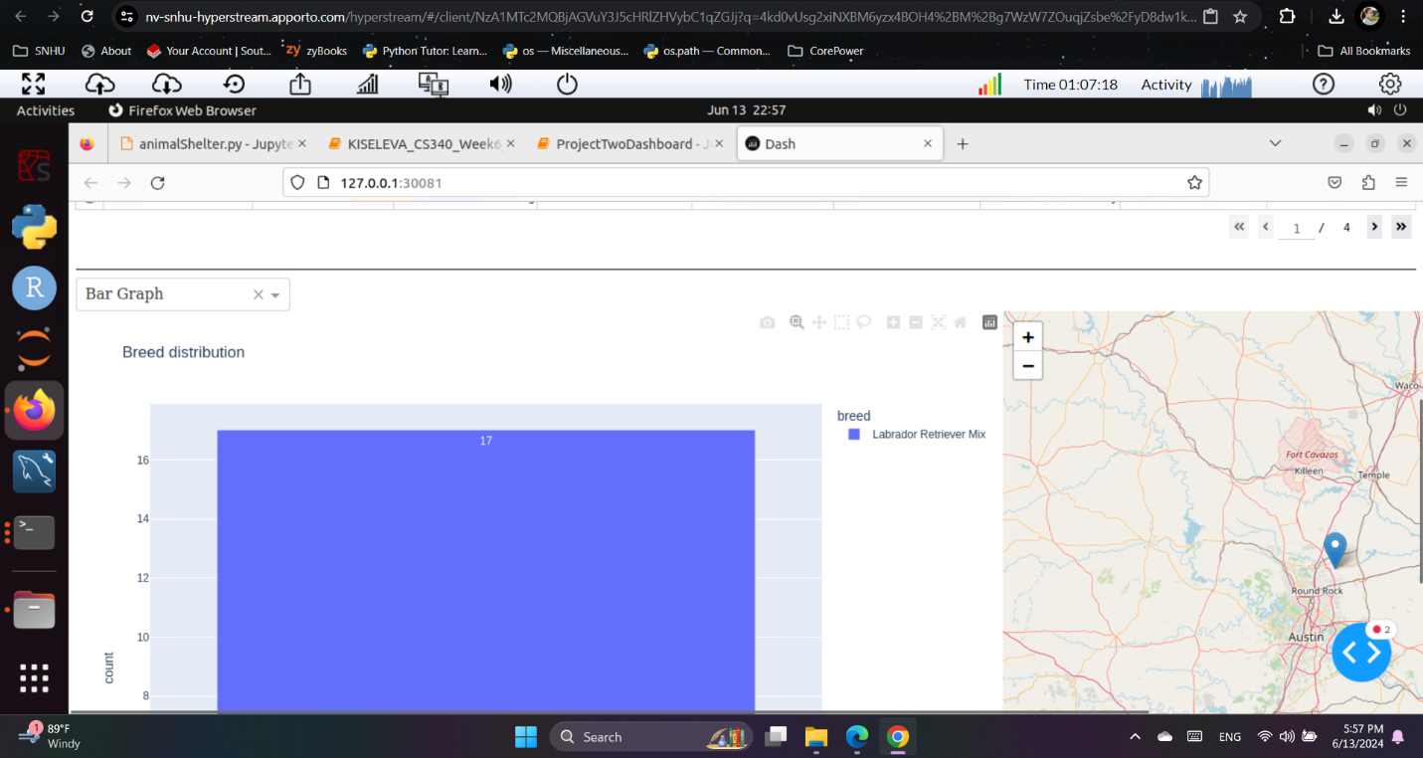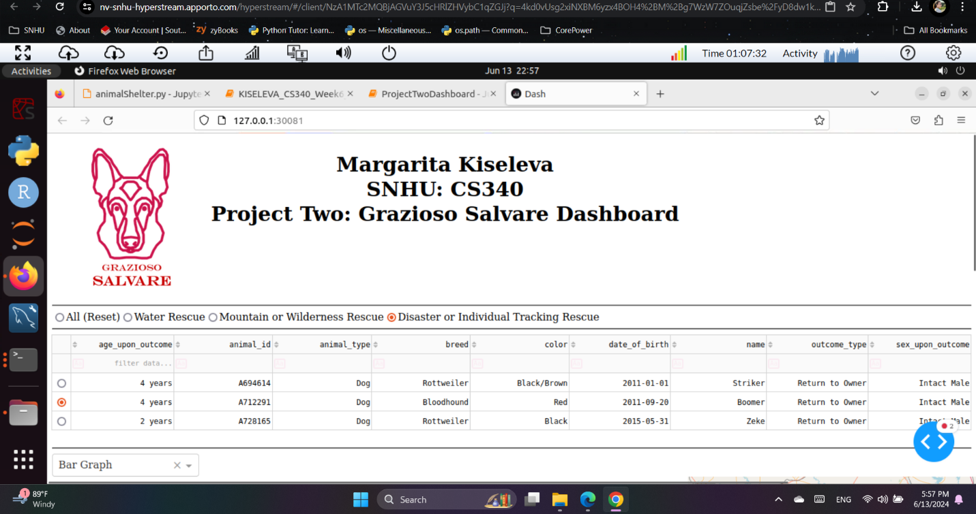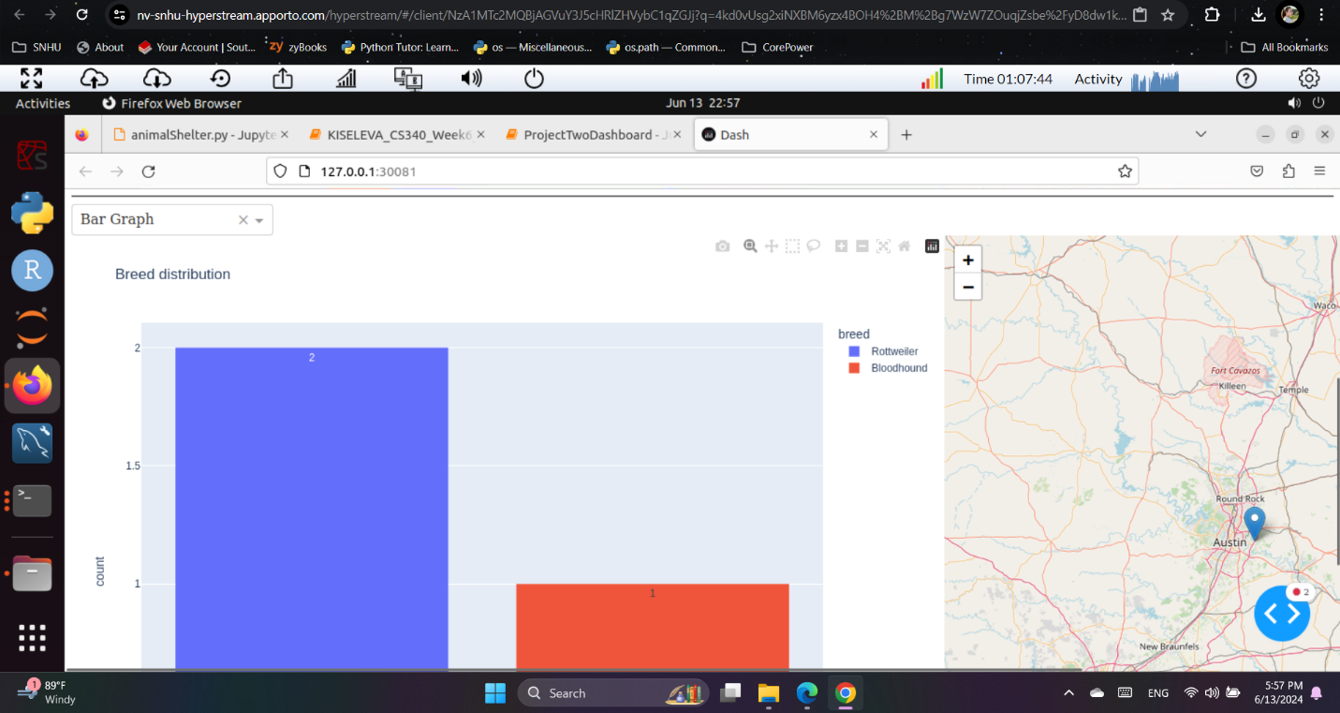

### **Contact**

Margarita Kiseleva

margarita.kiseleva@snhu.edu